Healthcare Appointment Scheduling BI System Design
Executive Report
Prepared By:
Jose Reyes
MS Business Analytics & Artificial Intelligence
University of Texas Rio Grande Valley
May 2026

Executive Summary
INFS Scheduling Solutions operates a healthcare appointment scheduling call center that generates extensive transactional data daily. Although the organization captures detailed information on call activity, appointment type, representative performance, marketing source, revenue, and outcomes, these transactions originally existed across separate systems. This fragmentation limited the organization’s ability to move from reactive reporting to proactive, data-driven decision-making.
The Business Intelligence (BI) solution developed throughout this course integrates operational data into a structured and scalable architecture. Transactional appointment data was first normalized into relational entities to eliminate redundancy and maintain data integrity. The operational database then feeds into a centralized data warehouse structured using a star schema. A central fact table captures measurable metrics such as appointment revenue and completion status, while dimension tables include representative, service type, date, and provider information.
An OLAP cube enables multidimensional analysis through hierarchical drill-down (Year → Quarter → Month → Day → Representative), allowing management to identify performance fluctuations across time periods and representative-level revenue differences. Predictive modeling using decision trees demonstrated that weekend appointments show both higher completion rates and higher expected revenue compared to weekdays. By integrating these components, INFS Scheduling Solutions transitions from basic reporting to strategic intelligence aligned with organizational goals.

Business Problem
INFS Scheduling Solutions manages inbound healthcare leads and schedules in-home and virtual evaluations. The organization collects detailed data related to appointments, representative performance, revenue, marketing sources, completion rates, and scheduling patterns. However, without an integrated BI system, the data lacked centralized visibility and strategic alignment.
This project integrates all prior unit work into a complete BI system designed to support executive and operational decision-making.

Major Business Decisions Supported

Service Type Prioritization
Analysis demonstrated that in-home appointments generate significantly higher revenue than virtual appointments. The BI system supports strategic prioritization of high-value services and targeted representative coaching.

Staffing and Scheduling Optimization
OLAP analysis enables management to identify high-performing representatives and strategically schedule them during peak periods to maximize revenue outcomes.

Performance Management and Coaching
Representative-level performance metrics allow leadership to implement targeted coaching and incentive-based strategies.

Predictive Scheduling Strategy
Decision tree analysis revealed that weekend appointments produce higher completion rates and revenue, supporting proactive staffing and scheduling decisions.

Transactional Database

Database Design and Structure
The operational database was normalized to eliminate redundancy and ensure data integrity. Core entities include Appointment, Representative, Service, Customer and Provider. Each entity contains a primary key, while foreign keys establish referential integrity across tables.
Relationships include one-to-many connections between representatives and appointments, service types and appointments, and provider and appointments. This relational structure ensures accurate transactional capture and consistent reporting.

Data Mart Design

Star Schema Structure
A data mart was developed using a star schema architecture. A central fact table captures measurable metrics including appointment revenue, appointment count, and appointment completion indicators. Surrounding dimension tables include Representative, Customers, Service, and Provider.
This structure supports efficient aggregation, simplified querying, and enhanced analytical processing.
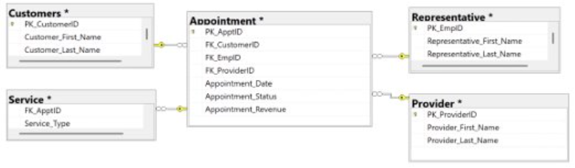
Figure 1: Star schema architecture for the healthcare scheduling data mart showing relationships between the central appointment fact table and surrounding dimension tables.

OLAP Cube Development

Measures and Dimensions
The OLAP cube includes the following measures:
Total Revenue
Representative Performance
Service Type Comparison
Dimensions include Date (Year → Quarter → Month → Day)

Analytical Insights
Hierarchical drill-down analysis revealed monthly revenue fluctuations and representative-level performance differences. In-home services consistently generate higher revenue over time periods.
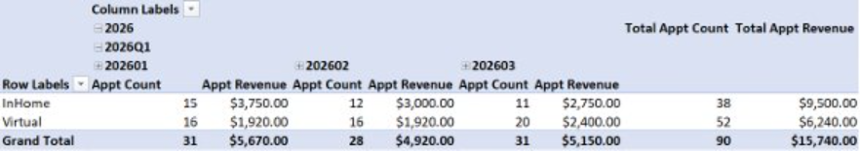
Figure 2: OLAP cube analysis comparing appointment count and revenue trends across service types over multiple monthly periods.
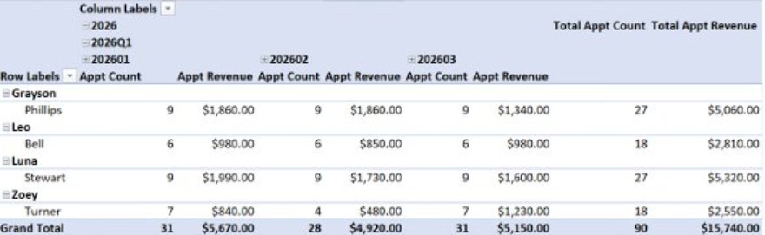
Figure 3: Representative-level OLAP analysis displaying appointment counts and total revenue performance across reporting periods.

Mining Structure and Predictive Modeling

Decision Tree Methodology
A decision tree model was implemented to predict revenue and completion status. Input variables included service type and day type (weekday versus weekend).
Key Predictive Findings
The model indicated that weekend appointments demonstrate higher completion rates and expected revenue, particularly for in-home services. These predictive insights allow management to optimize scheduling and staffing decisions proactively.
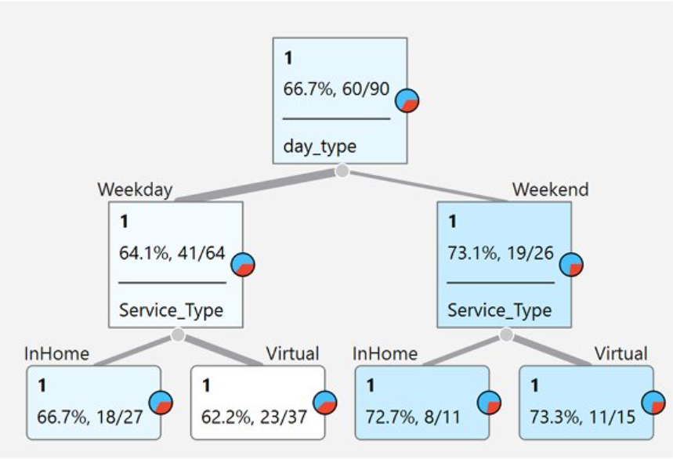
Figure 4: Decision tree classification model predicting appointment completion outcomes based on day type and service type variables.

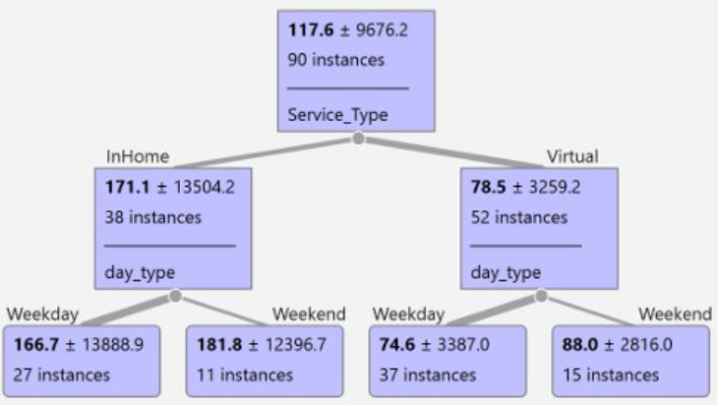
Figure 5: Decision tree regression model illustrating predicted revenue outcomes across service types and scheduling periods.

Conclusion
This integrated Business Intelligence system demonstrates how transactional data can be transformed into strategic decision support. By combining relational database design, star schema warehousing, OLAP multidimensional analysis, and predictive modeling, INFS Scheduling Solutions transitions from reactive reporting to proactive, data-driven management.
The system enables improved revenue optimization, staffing allocation, performance management, and alignment between operational performance and long-term strategic objectives.

